**Advising System**

**Features**

1. The advisor creates a schedule for the entire duration of the MBA program for every student/advisee
2. The registrar would update the courses offered every semester so that the students can choose which class they want to take
3. The advisor can assist the student in choosing classes
4. The student can decide which class to add or delete
5. The registrar will enroll the student in the classes he chose to take
6. If the student decides to drop a class after the semester starts, the administrator will have to give his/her approval

**Requirements**

1. The system can be accessed by any platform: desktops, laptops, mobile phones and tablets
2. The system has to be supported by both Windows and Apple operating systems
3. The student should be able to make changes
4. The advisor should be able to see the changes the student makes
5. The registrar should be able to see the changes the student makes and update the system
6. Every user should have his/her own individual login information
7. An e-mail should be sent to the student every time a change is made by the registrar or administrator

PERT Diagram

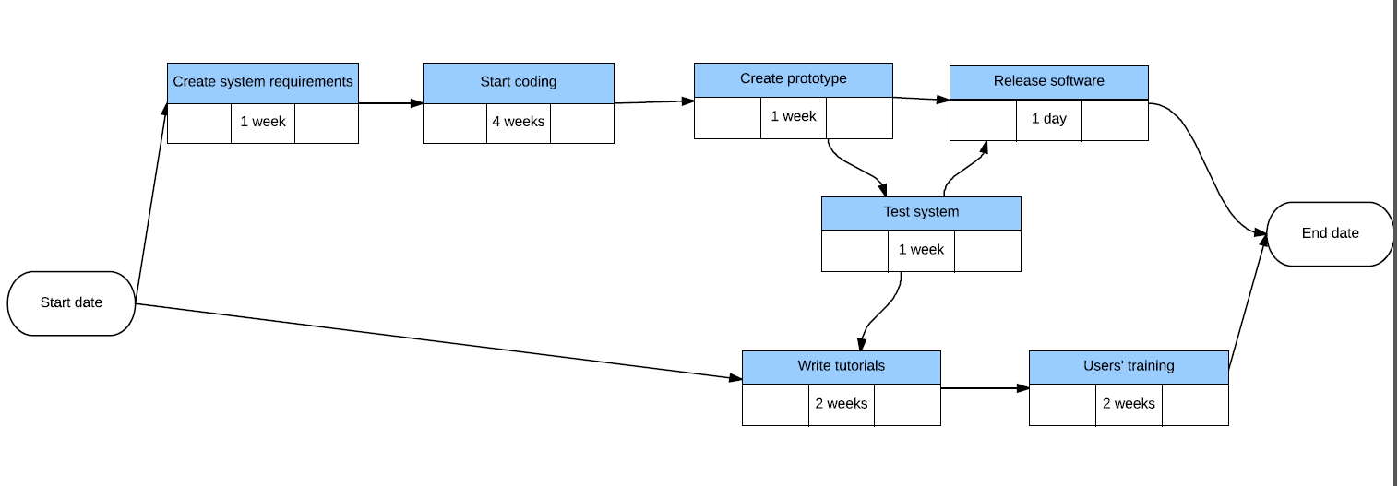

Gantt Chart

